**DOKUMENTASI WEBSITE**

**SERTIFIKASI VSGA YOGYAKARTA 2024**

**MUHAMMAD AZID FADHIL NABHANI**

1. 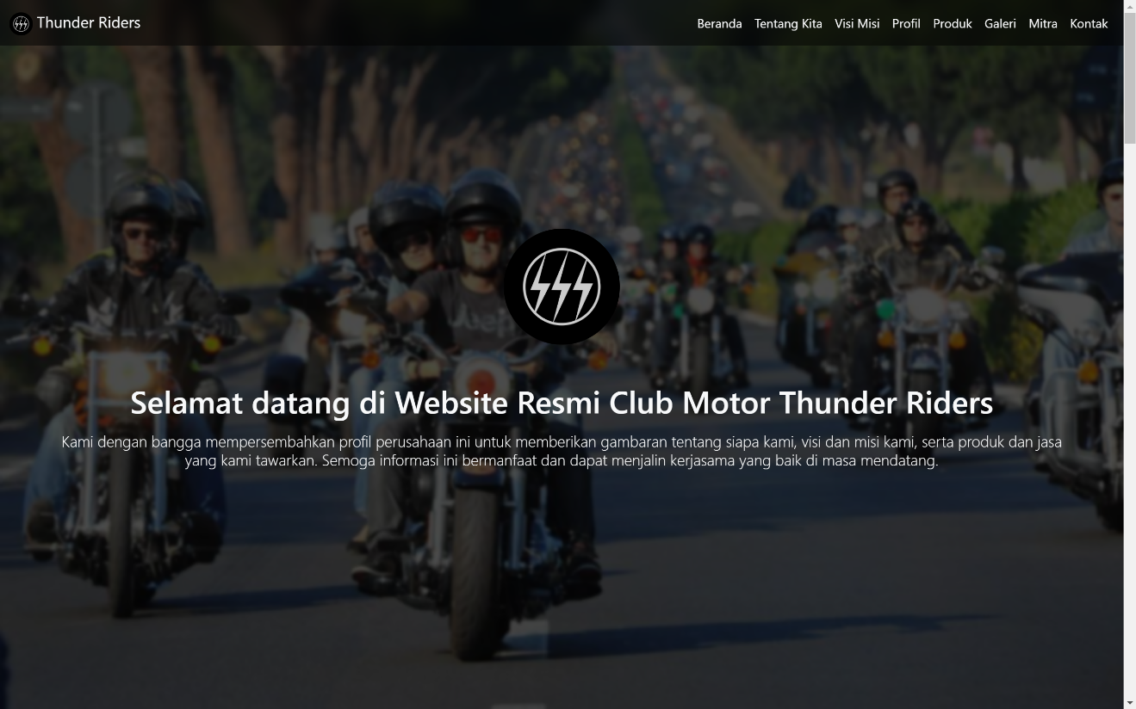Cover
2. 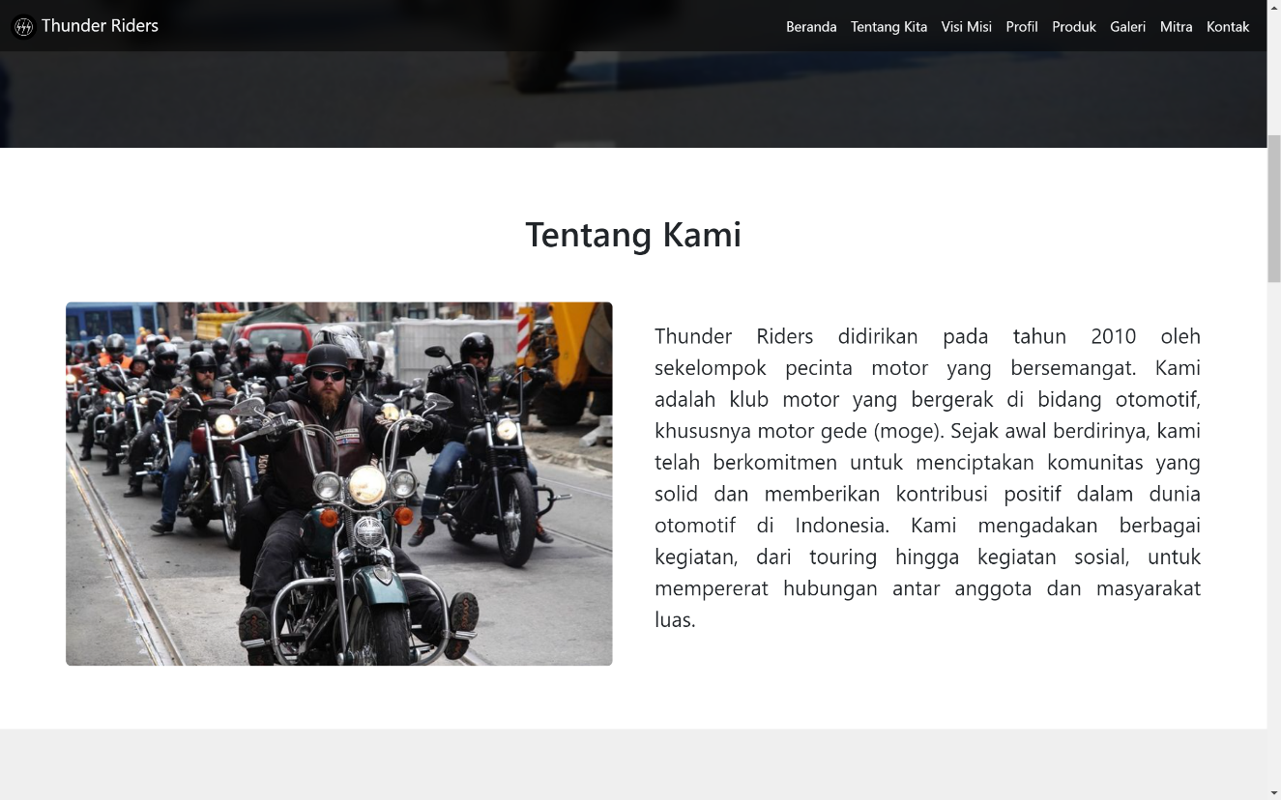About Us
3. 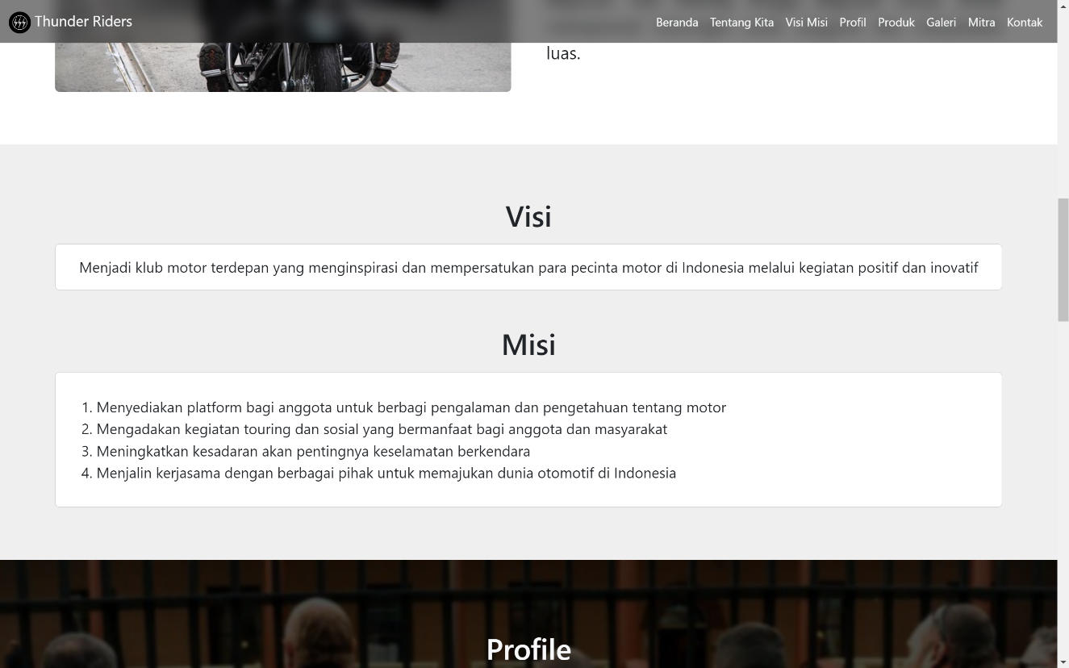Visi Misi
4. 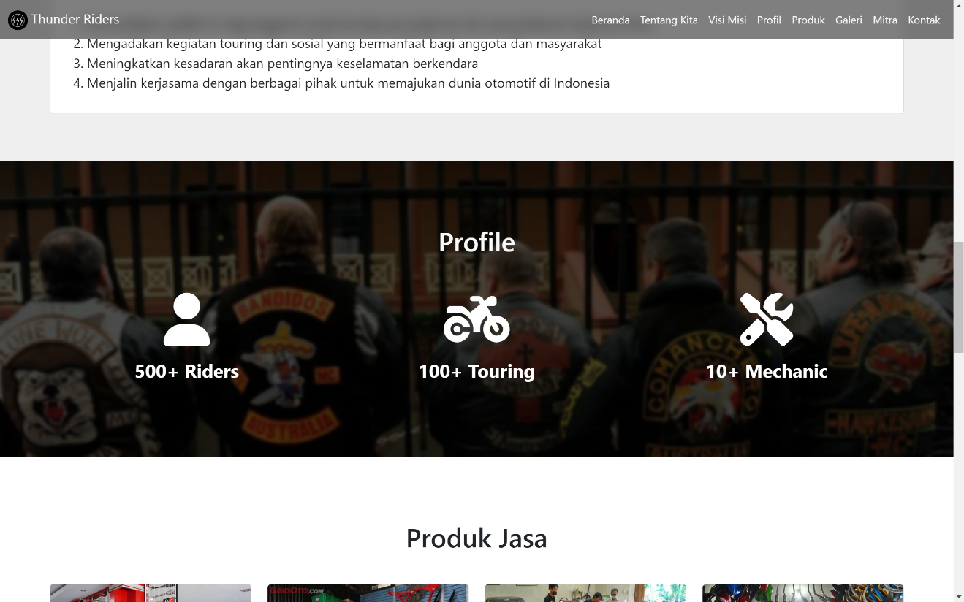Profile
5. 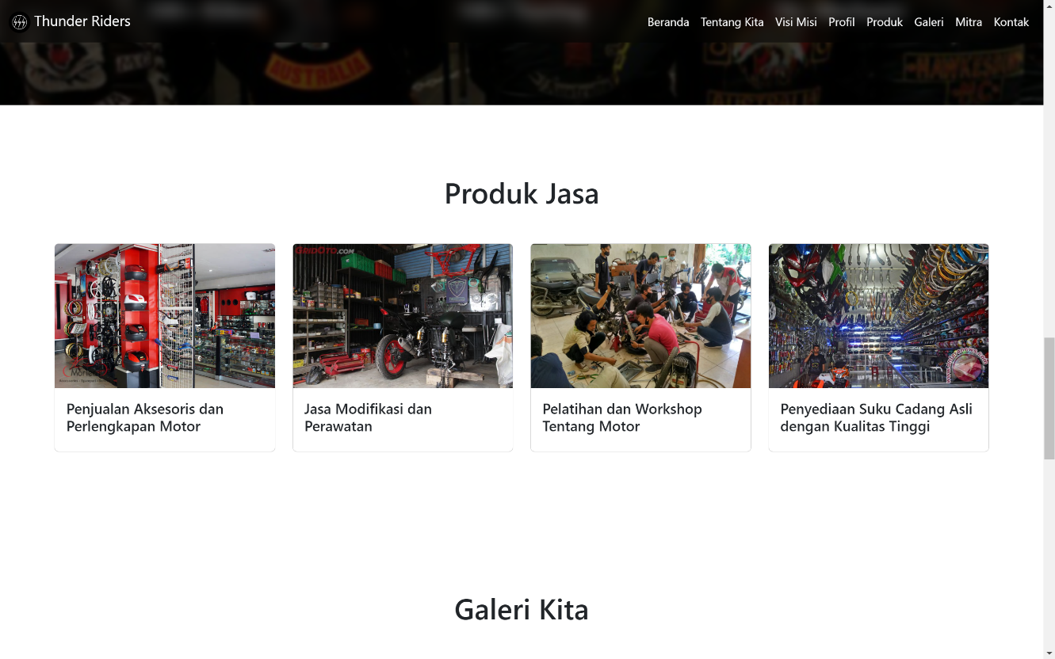Produk dan Jasa
6. 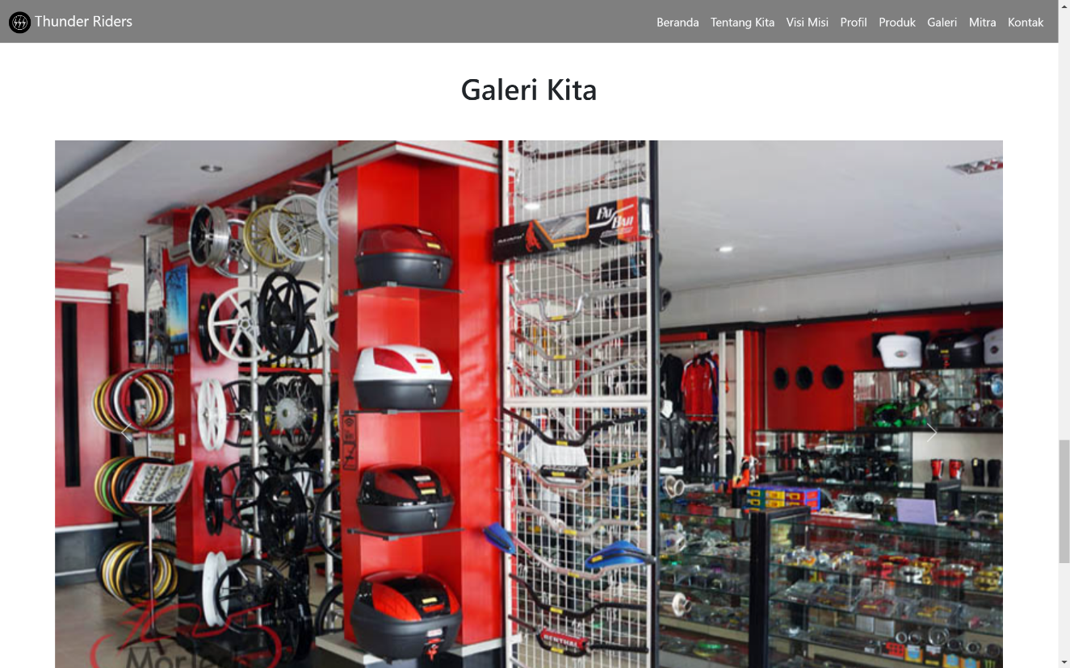Galeri
7. 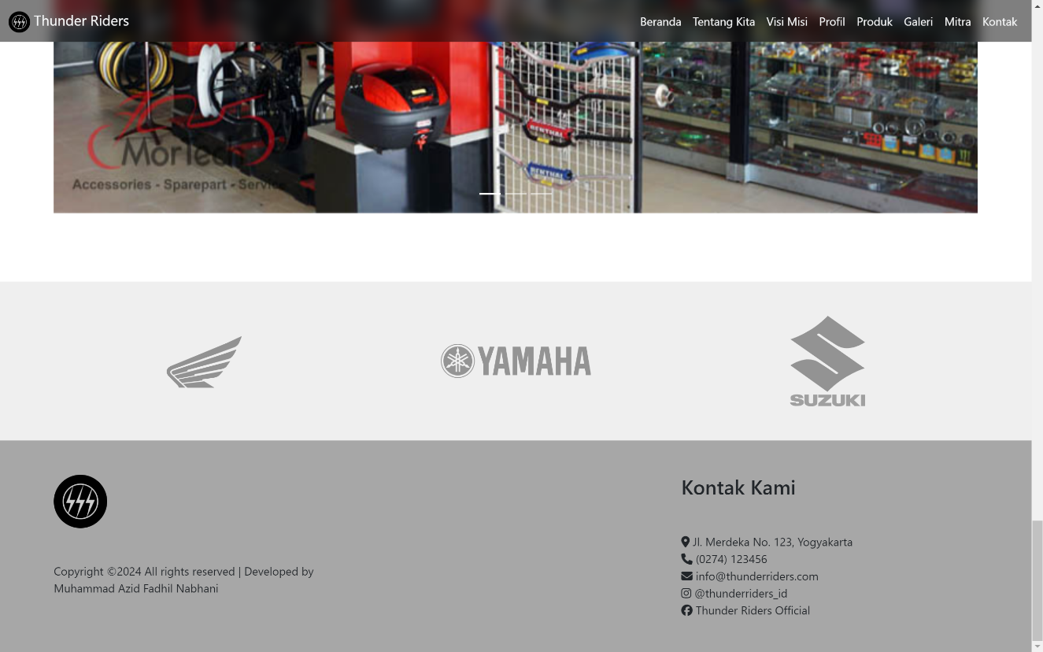Mitra/Klien
8. Kontak

Source code :

<https://github.com/azidfadhil/simple-landing-page>

Another website code :

<https://github.com/azidfadhil>